# HOL 6 : Monitoring, Scaling & Updating application deployed on kubernetes.

**Objective:**

**Monitor the existing application, Scale [manual / automatic] and updating deployment.**

**Duration: 30 Minutes**

**Prerequisites:**

1. Azure Subscription
2. Internet Connection
3. SSH Client (Ubuntu Bash or Git Bash)
4. Web Browser (Any)
5. Text editor (Visual Studio code recommended)

**Steps:**

1. Launch Azure VM and Start the (Previously stopped) cluster.
2. From Azure portal, goto DockerVM2 and Click “Start” to Start VM
3. Once VM Started, connect using SSH
4. Once connected, use following command to start the existing cluster

$ sudo minikube start

$ sudo minikube status

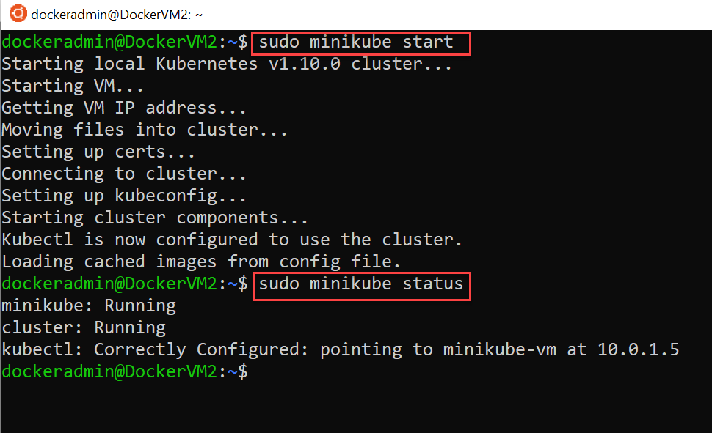

1. Build a sample CPU intensive application
2. Create a folder “heavy-app” 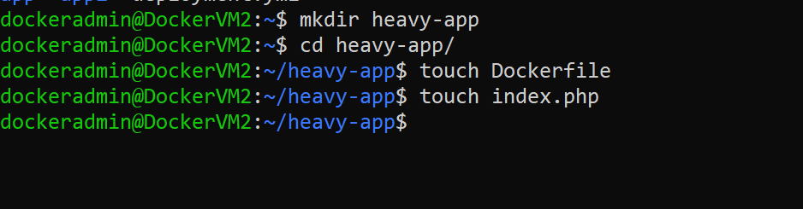
3. Create a new Dockerfile with following contents:

Use $ nano Dockerfile

OR $ vi Dockerfile

FROM php:5-apache

ADD index.php /var/www/html/index.php

RUN chmod a+rx index.php

1. Create index.php page with following code:

Use $ nano index.php

OR $ vi index.php

<?php

$x = 0.0001;

for ($i = 0; $i <= 1000000; $i++) {

$x += sqrt($x);

}

echo "OK!";

?>

1. Build a container image

$ docker build -t app-image .

1. Deploy this new application using kubectl command:

$ sudo kubectl run heavy-app --image=app-image --requests=cpu=200m --expose --port=80

Test the deployment using command:

$ sudo kubectl get deployments

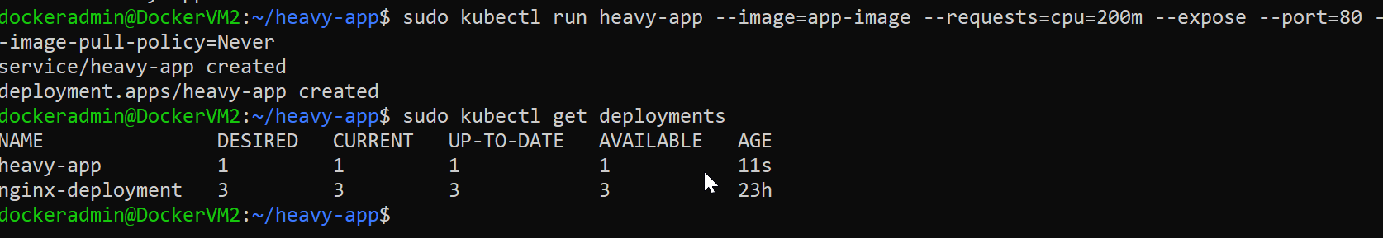

Monitor deployed application using kubernetes dashboard

$ sudo minikube dashboard

Open web browser and access URL : <VM-Public-Ip>:30000

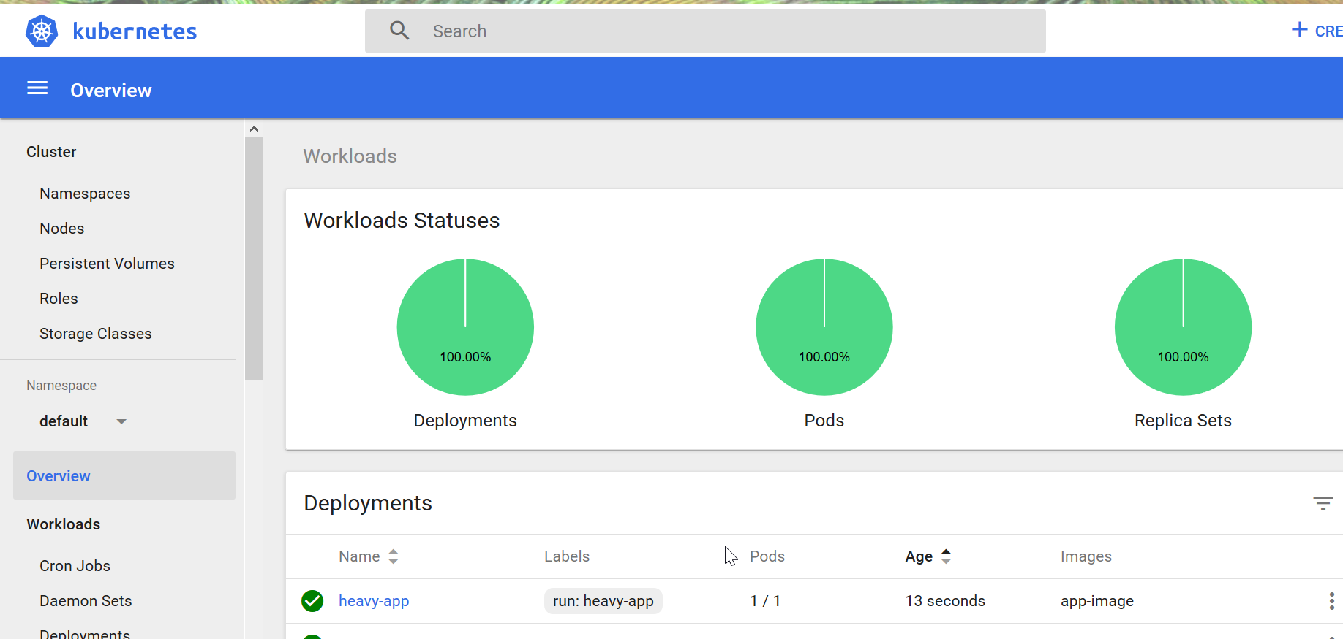

1. Autoscale & Monitor the deployment
2. Goto terminal and type following command to set auto-scale

$ sudo kubectl autoscale deployment heavy-app --cpu-percent=50 --min=1 --max=10

1. open dashboard for deployment heavy-app

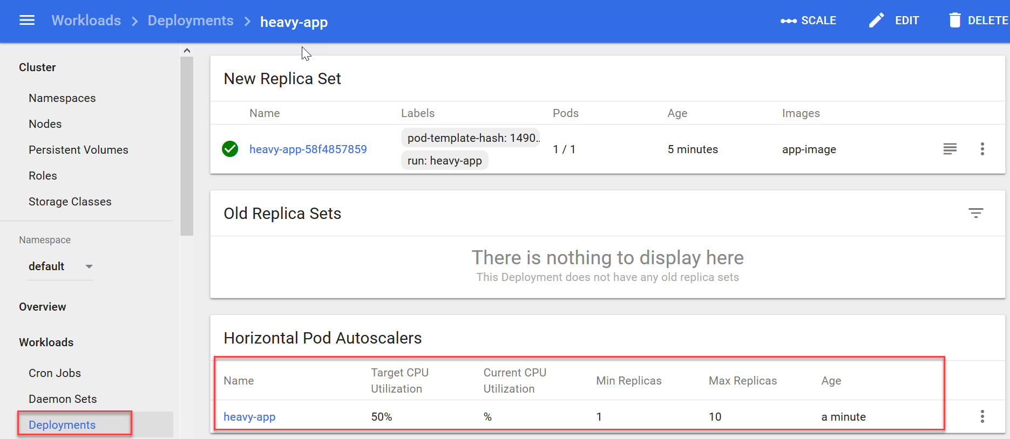

1. Update the deployment
2. On Dashboard click on deployments > heavy-app then click “edit” button

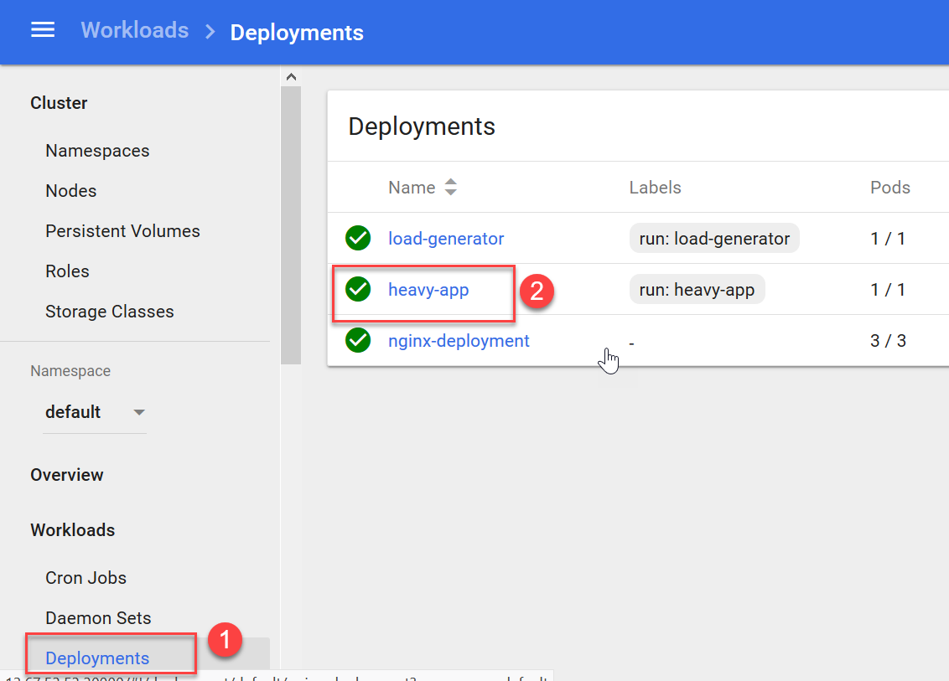

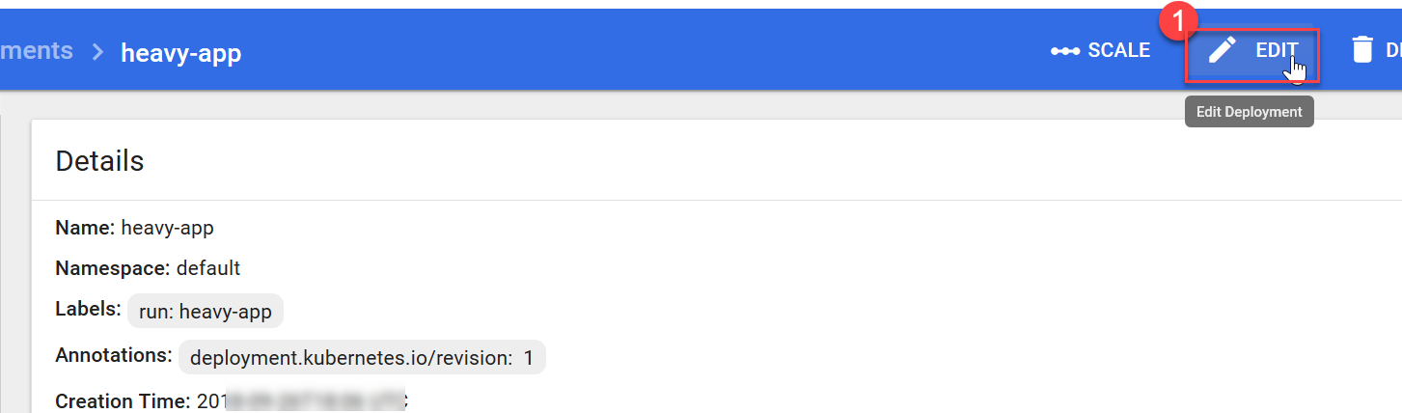

1. Edit the property “replicas”, change value from “1” to “2” and click Update

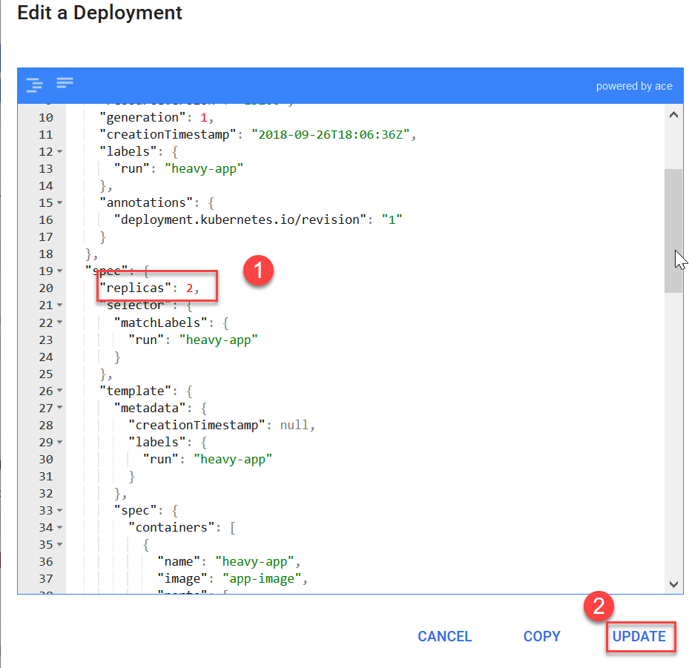

Update in Process can be seen on dashboard

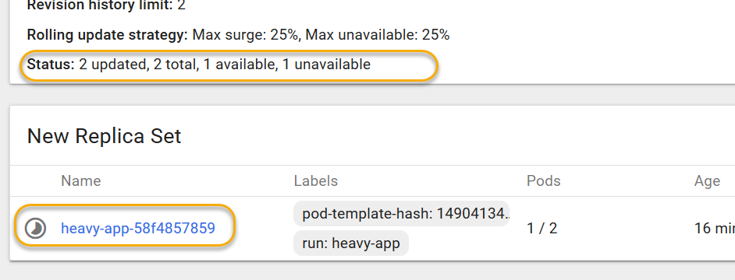

Clean Up:

Shutdown the minikube cluster using following command before VM shuts down:

$ sudo minikube stop